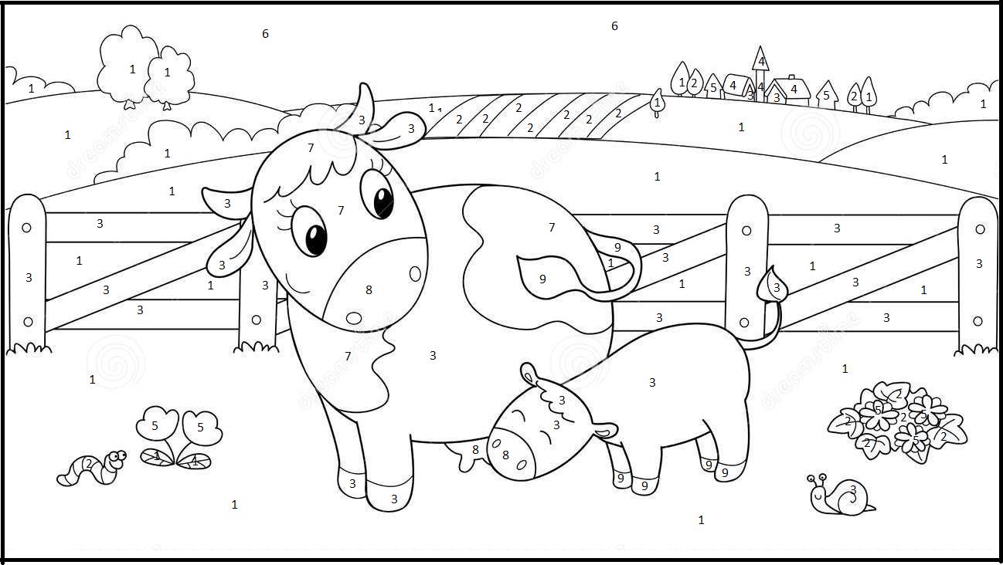

8 Pink

9 Black

7 White- biały

6 Light blue

5 Red

3 Brown

4 Blue

2 Light green

1 Green